LFS Unit-Level Engagement Process with ISP Self-Assessment Tool
August 2022

In 2020, UBC released the Indigenous Strategic Plan (ISP), which outlines eight goals and 43 actions the university will collectively take to advance its vision of UBC as a leading university globally in the implementation of Indigenous peoples’ human rights.

To support the practical implementation of ISP goals and actions, the ISP Self-Assessment Tool provides units with the opportunity to reflect and discuss their role at UBC within the context of Indigenous engagement. Completing this tool will help to situate units in relation to ISP goals and actions and will help answer questions such as:
• What are we currently doing to advance the goals and actions of the ISP?
• What can we be doing more of?
• What are we doing that we can change?
• What can we start doing?

In the Faculty of Land and Food Systems, our goal is to have all units complete the Self-Evaluation Tool by March 31, 2023. The following guidelines and templates will help each unit achieve this goal.

From the ISP Self-Evaluation Tool document (p. 04)
Ultimately, the Self-Assessment Tool will help units to start conversations around these important topics, identify what their next steps could be in implementing the ISP, and lead into Step 3 of the toolkit: the Intent to Action Tool.

Stage | Activity | Output
Pre-Meetings + Planning | - Review pages 4-8 in the tool to prepare for engaging as a facilitator and as a unit  - Reach out to other individuals in your unit to see if there is interest in co-leading/co-facilitating the process. Schedule a meeting to discuss the plan below!  - Have “ISP Self-Evaluation Tool Engagement Plan” placed on the agenda of your unit’s meeting (suggested: 20-30mins needed)  - In preparations, ask each member of the unit to review the ISP Self-Evaluation Tool document and Pre-Workshop Resources embedded within (see page 3) | - Individual (or group of individuals) identified as leading process  - ISP Self-Evaluation Tool on agenda  - Each member of unit
First Unit Meeting | - Working backwards from the LFS Milestones (see below), discuss how the unit can realistically meet these completion goals. For example,  - Setting aside 30mins of existing standing meetings to work through each of the five sections of the tool  - Scheduling 2-hour meetings, monthly or bi-monthly, to focus specifically on the self-assessment tool  - Scheduling a half-day or full-day retreat to complete the tool  - Once a schedule has been established, fill in template provided and send to AD, EDI.I  - Send calendar invites and communication strategies (e.g., email reminders, nudges through internal communication platforms, etc.) to keep the momentum going. This will increase the likelihood that your unit meets its target completion dates | - ISP Self-Evaluation Tool schedule for completion, sent to AD, EDI  - Calendar invites to unit members  - Communications plan
Working through ISP Self-Evaluation Tool | - Record meeting outputs through the template. Notice that the template has 3 sections.  - Begin with a check-in to capture what has emerged in the process of each individual’s engagement. This is an important step. It is a strategy for encouraging different perspectives to be heard, to give space for uncertainty, and to demonstrate accountability in process.  - Record your unit’s responses to the individual self-assessment tool questions  - Close the session with a reflection on process (e.g., is the pace ok? Are the instructions clear? etc.) and insights (e.g., what emerged from this round of engaging with the tool? New insights? New questions? New futures?)  - Synthesize key themes from the process of engaging with the tool, final responses, and identify possible next steps in implementing the ISP (and leading into Step 3 of the toolkit: Intent to Action Tool)  - Send final report to Associate Dean, EDI | - Completed template documents for each meeting  - Final document summarizing key themes, final responses, and next steps sent to AD, EDI

Milestones
October 3, 2022
- 100% of LFS units have submitted an ISP Self-Evaluation timeline to the Associate Dean, EDI
January 09, 2023
- 50% of units have completed the ISP Self-Evaluation
- 50% of units in LFS have completed 50% of the ISP Self-Evaluation
March 31, 2022
- 100% of units in LFS have completed the ISP Self-Evaluation

Resources
- [PDF] UBC Indigenous Strategic Plan
- [PDF] UBC ISP Self-Evaluation Tool
- Truth and Reconciliation Commission of Canada Final Report & 94 Calls to Action
- The United Nations Declaration on the Rights of Indigenous Peoples (UNDRIP)
- Final Report of the National Inquiry into Missing and Murdered Indigenous Women
and Girls
- What I Learned In Class Today – A resource for educators
- Glossary of Terms Resource
- UBC Indigenous Peoples Language Guide

Template for Scheduling ISP Self-Evaluation Tool

UNIT:
LEAD(S):
MEMBERS:
TARGET COMPLETION DATE:

SCHEDULE OF COMPLETION
Once complete, send to AD, EDI by October 03, 2022
Date | Meeting | Topic
Sept 19, 2022 | Monthly Unit Meeting | ISP Self-Evaluation Tool Planning  - Review entire tool  - Review pre-workshop resources
October 17, 2022 | Monthly Unit Meeting | Complete 2 sections  - Understanding + People

COMMUNICATIONS STRATEGY
For example, do not need to send to AD, EDI
Date | Activity | Lead
Sept 12, 2022 | Send email reminder to complete section X before meeting on Sept 19
Sept 16, 2022 | Send reminder to complete section though MS Teams chat/Slack/WhatsApp
Sept 19, 2022 | Day of meeting reminder
Sept 20, 2022 | Email completed meeting template to AD, EDI, cc’ all members of unit

Template for Recording Meeting Outputs
*Complete A-D for each of the 5 sections of the ISP Tool, bundle into one file, and send to AD, EDI by March 31, 2023

Unit:
Date:
Participants:
Regrets:

ISP Self Evaluation Tool Sections
- Understanding (Qs 1-8)
- People (Qs 1-6)
- Culture and Systems (Qs 1-6)
- Relationships and Partners (Qs 1-7)
- Teaching, Learning and Research (Qs 1-8)

- Check-In
- Each individual takes 1min or so to speak to what they learned, what they are unsure of, or what they are excited about related to the themes of the section(s) from the tool
- Record key themes here

Theme | Quote/Example

- Responses
- Record section, question, rating, and notes

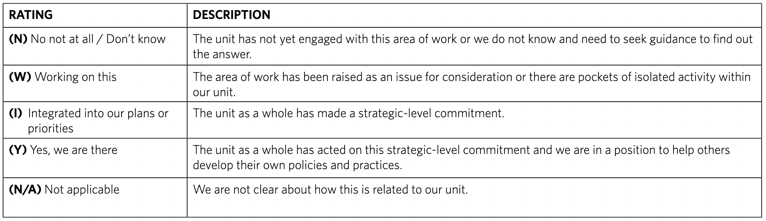
SECTION #
Question # | Rating | Notes
1
2
3
4
5
6
7
8

C. Reflection
- Each individual takes 1min or so to speak to what has emerged from the process of completing the section
- Record key themes here

Theme | Quote/Example

D. Review Schedule + Progress
- Review the unit’s schedule for completion.
- Is the unit on target, why or why not?
- Are all members of the unit engaged? Why or why not?
- What strategies need to be put in place to reach target completion date for everyone in the unit?

